

Brooke Uniform Policy and Resource

Below, you will find our uniform policy with examples of what the policy is referring to as acceptable articles of clothing that fit our policy. This resource continues on to list articles of clothing that are NOT in-line with the uniform policy.

Please use this resource to align yourselves with what teachers and staff will be looking to ensure our students are in uniform. For all questions and concerns regarding uniform, please email the Operations Coordinator, Maylin Pimentel, at maylin.pimentel@ebrooke.org.

The importance of school uniforms: School uniforms create a sense of equality among students by minimizing visible differences in clothing. Uniforms promote inclusivity and foster a sense of belonging among students. Uniform policies set a standard for student behavior and discipline as well as establishing a clear dress code. More importantly, our uniform fosters a sense of pride and identity within our school community, and we become identifiable representatives of Brooke. Lastly, uniforms prepare students for professional environments where dress codes are common–helping them to develop a sense of responsibility, self-discipline and understanding of appropriate attire for different settings.
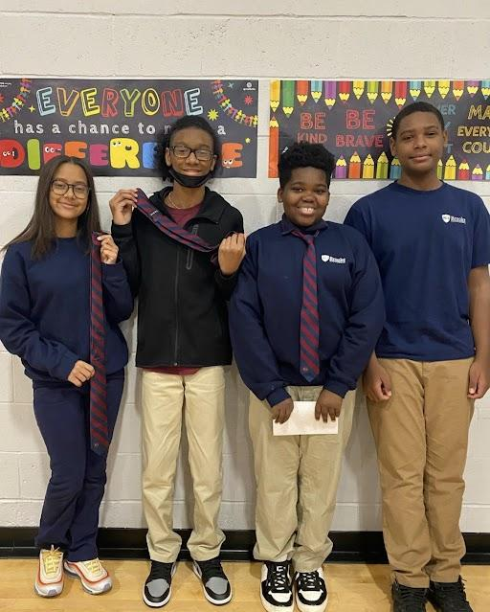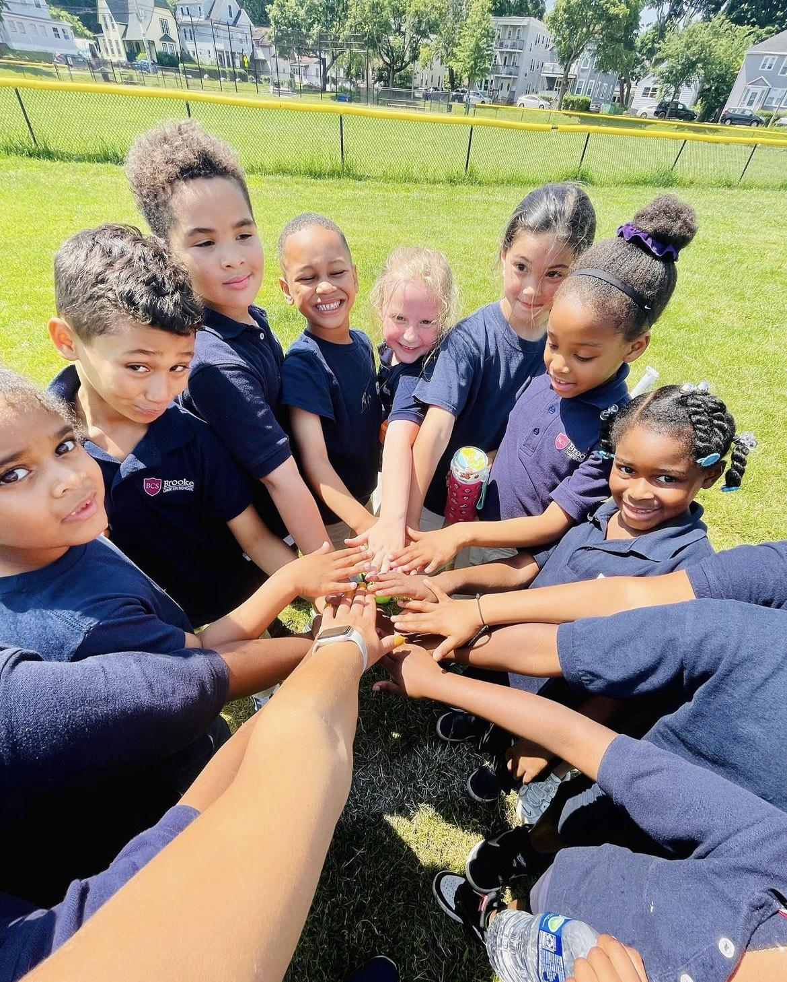
All scholars need to wear black, navy or khaki-colored uniform skirts, shorts or pants (i.e. no jeans, ripped pants or leggings): | 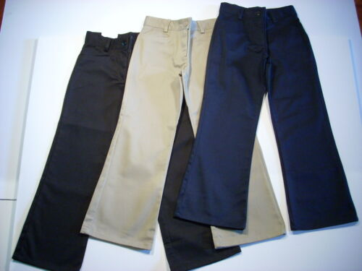
New this year: K-8th grade students can wear navy blue or black sweatpants (or navy blue gym shorts) with the Brooke logo | 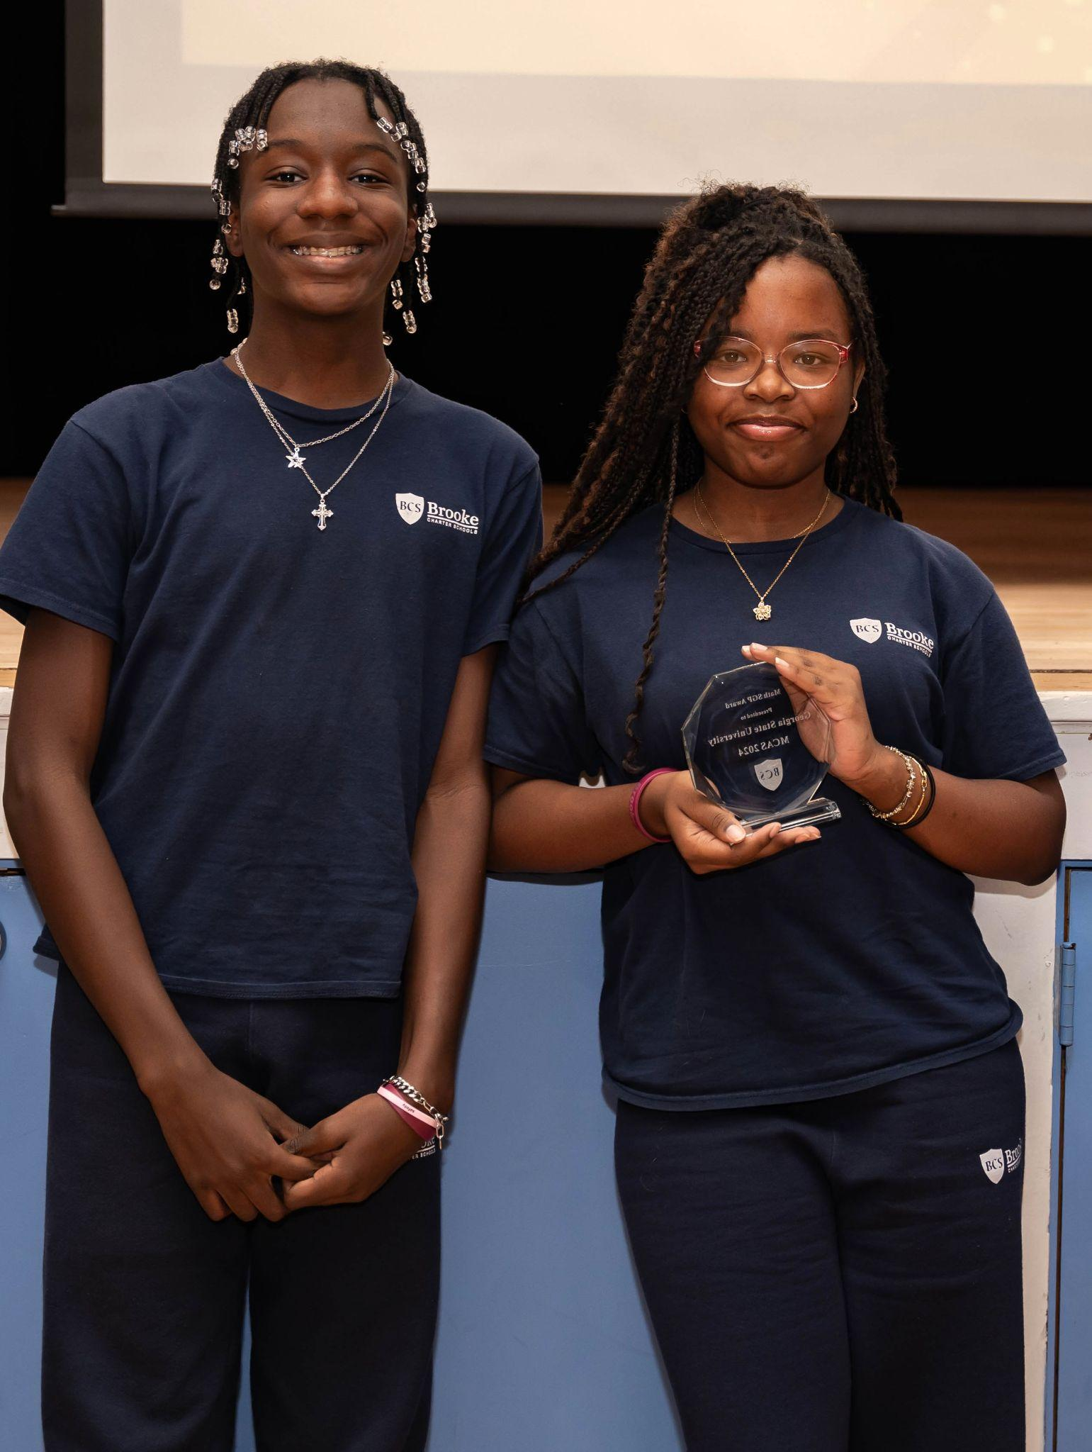
Skirts and shorts need to be knee length. We recommend that skirts be worn with shorts underneath. | 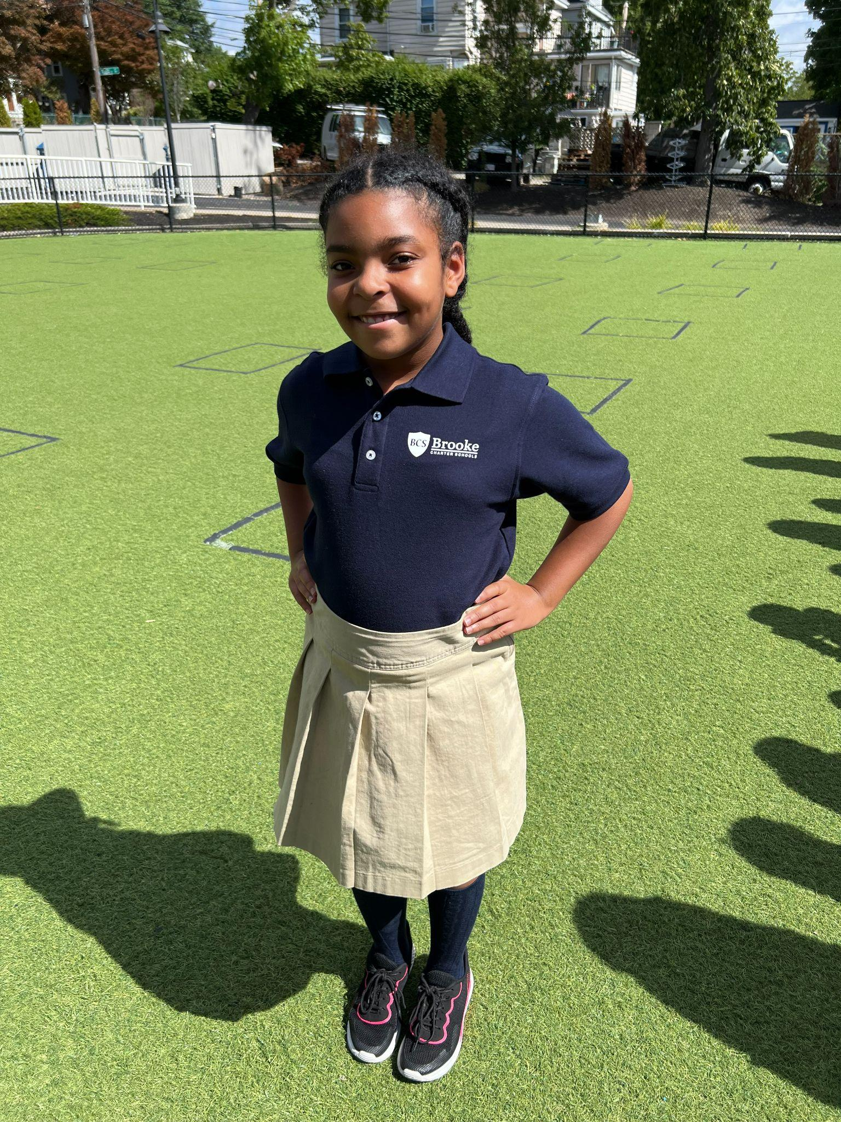
The only jumper that is acceptable is the navy-blue jumper from Lands’ End. | 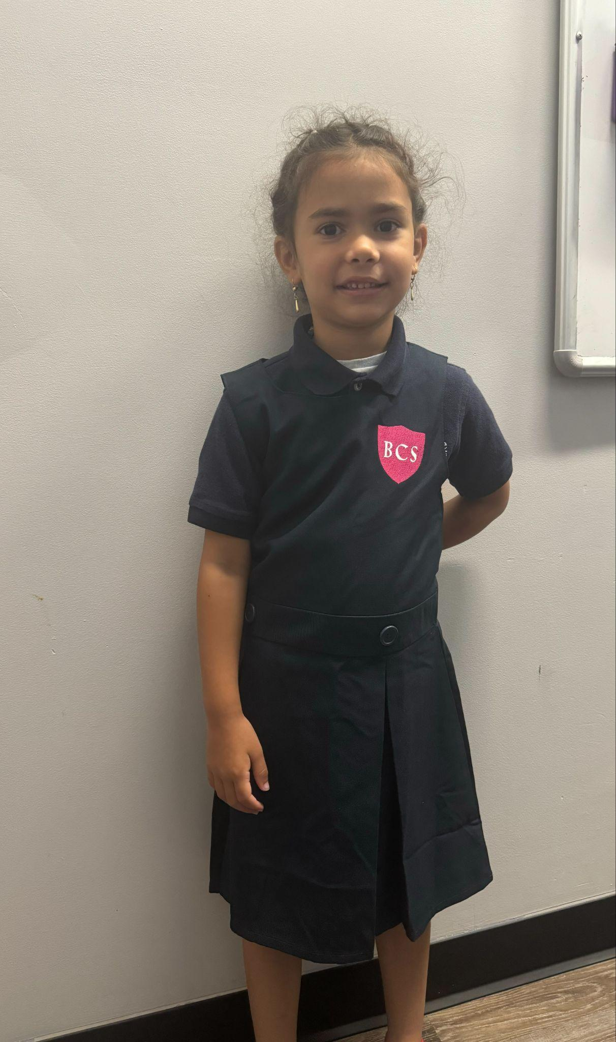
All scholars need to wear a navy-blue Brooke uniform shirt with the Brooke logo. (Long or short sleeve polo shirt, or long or short sleeve t-shirt)  Our Lands’ End and CustomInk stores will have the Brooke shield logo. | 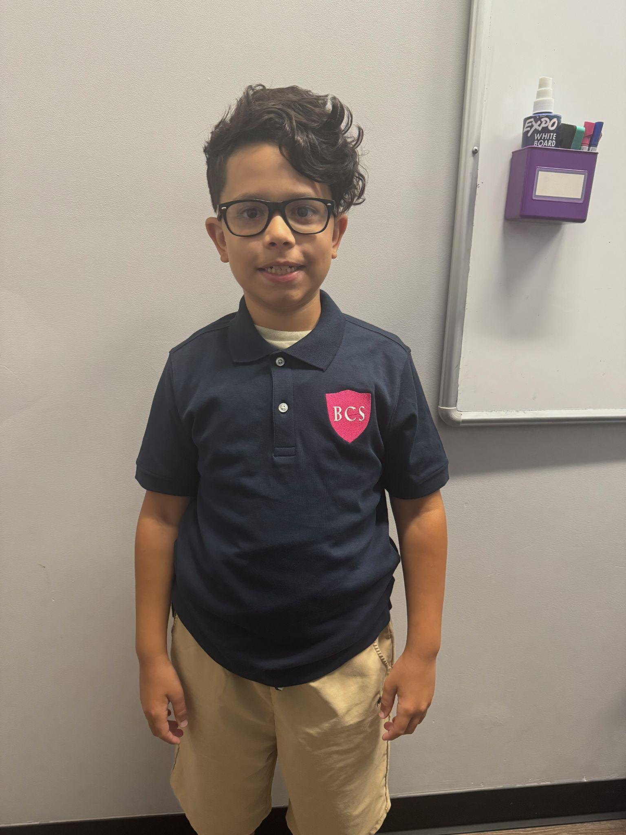  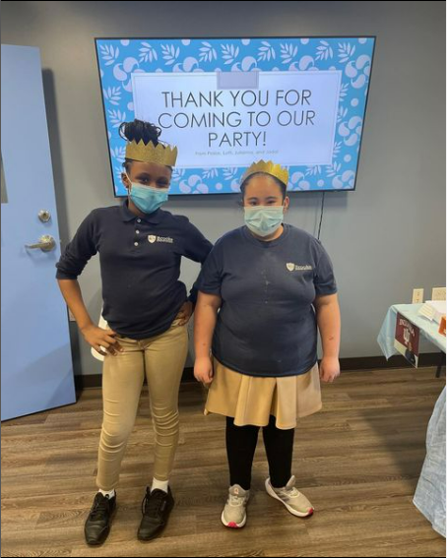
Sweaters and Sweatshirts:  - Scholars can only wear Brooke Roslindale sweaters and sweatshirts. You can purchase these from our uniform vendors. We offer crewneck sweaters and sweaters as well as hoodies. | 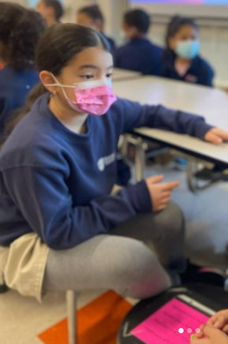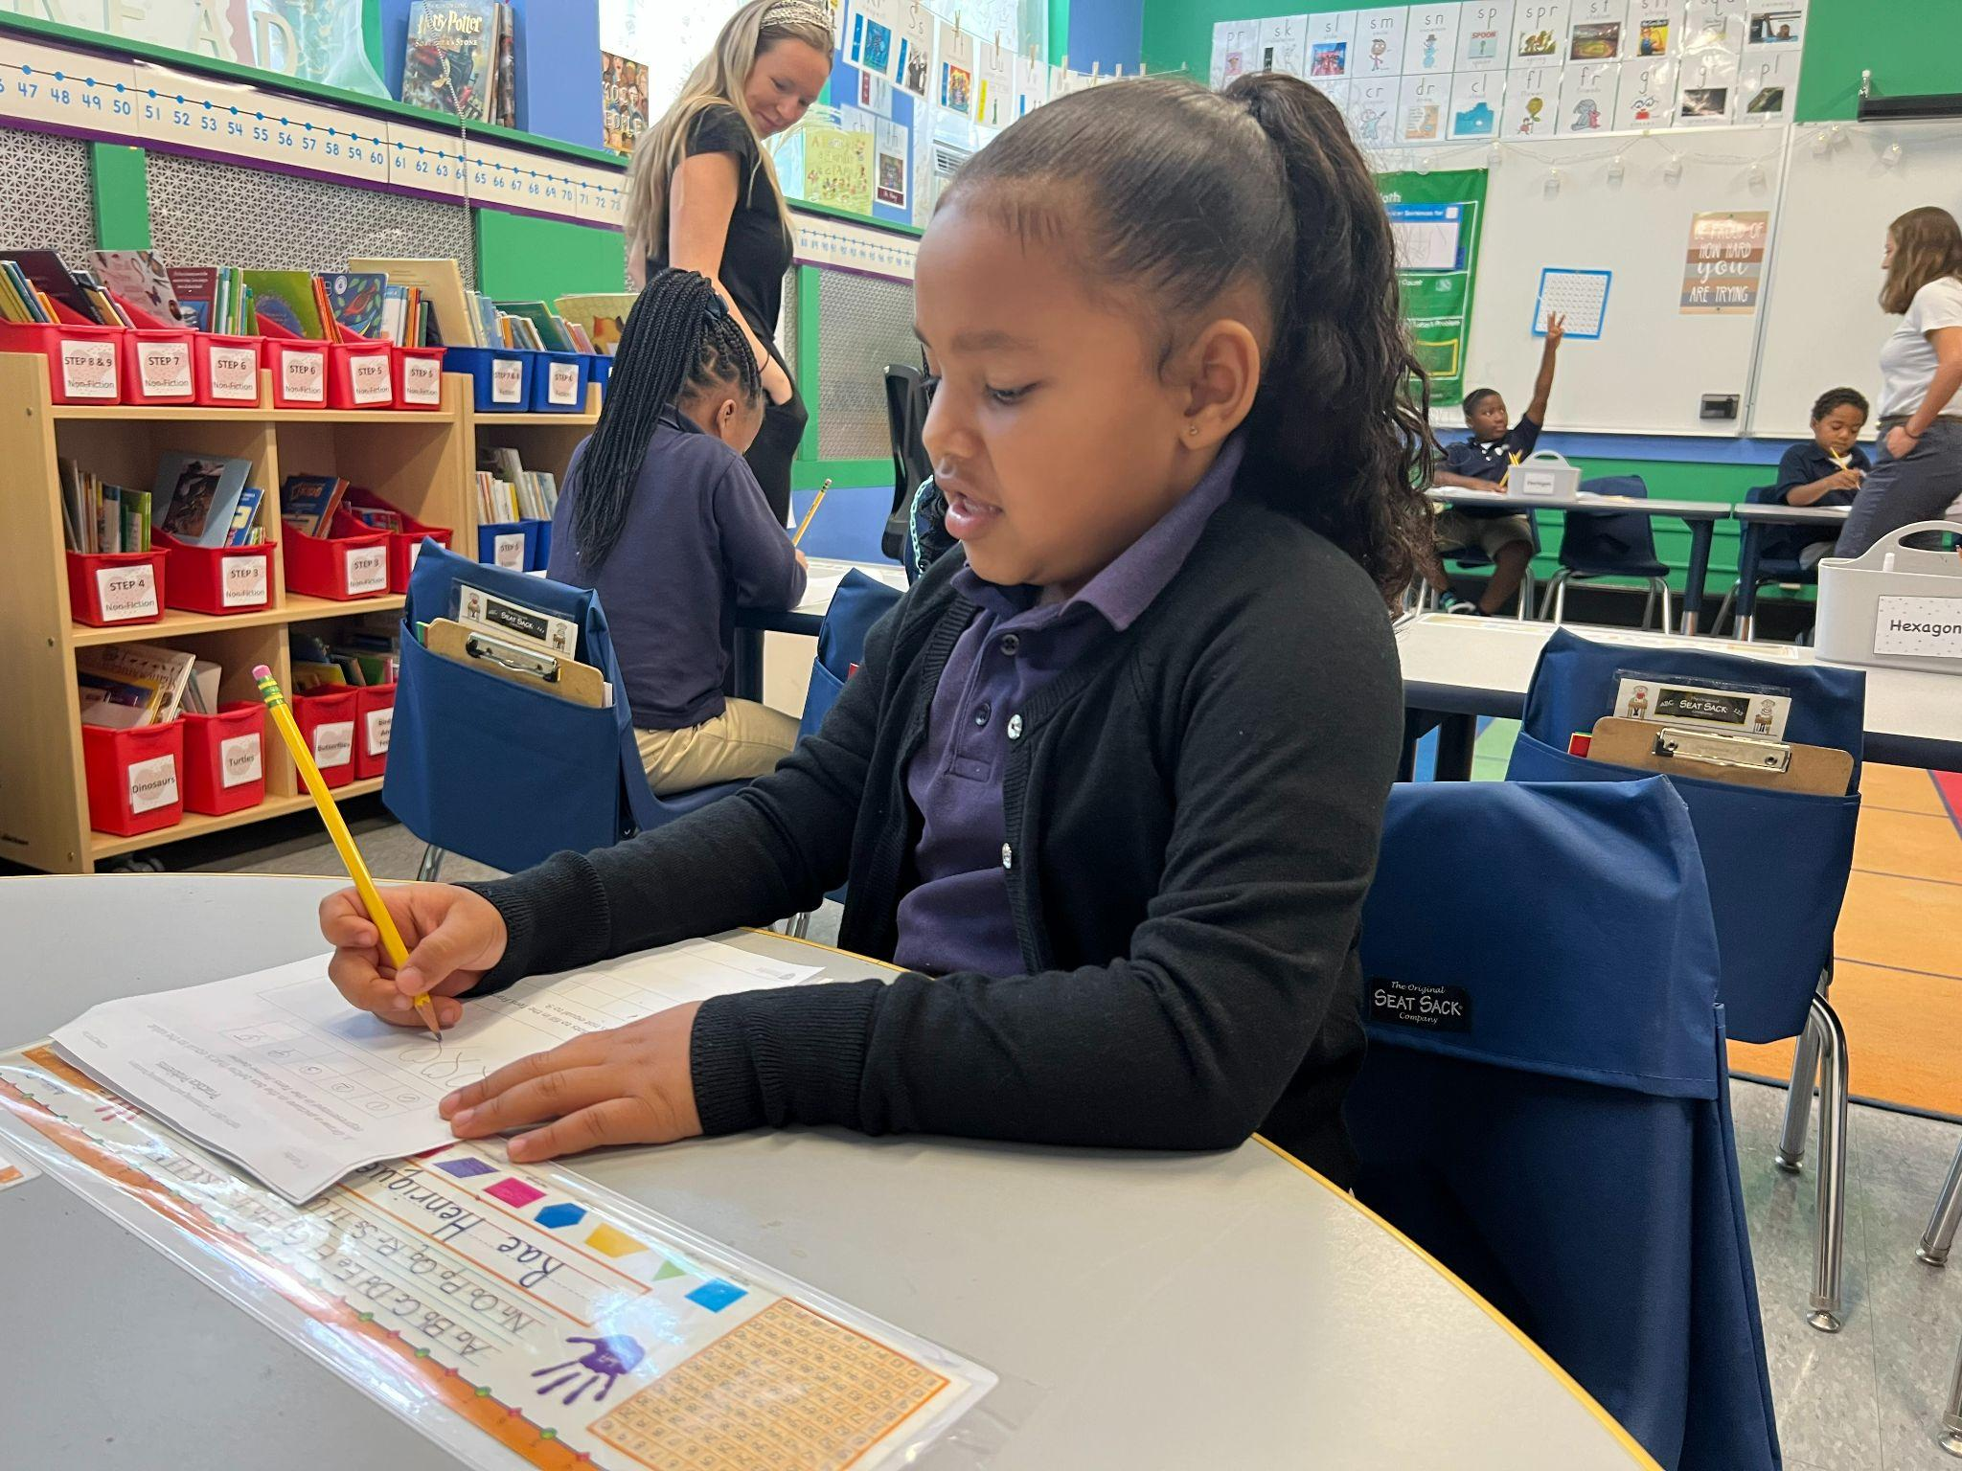
Footwear:  - All scholars need to wear sneakers.  - Scholars can wear any sneakers as long as they don’t light up or have wheels.  - If scholars wear boots to school, they need to bring sneakers to change into. | 
Socks, tights and undershirts: Socks can be any color if a scholar is wearing pants. If a scholar is wearing shorts or a skirt, the socks need to be solid navy, white, black or gray. | 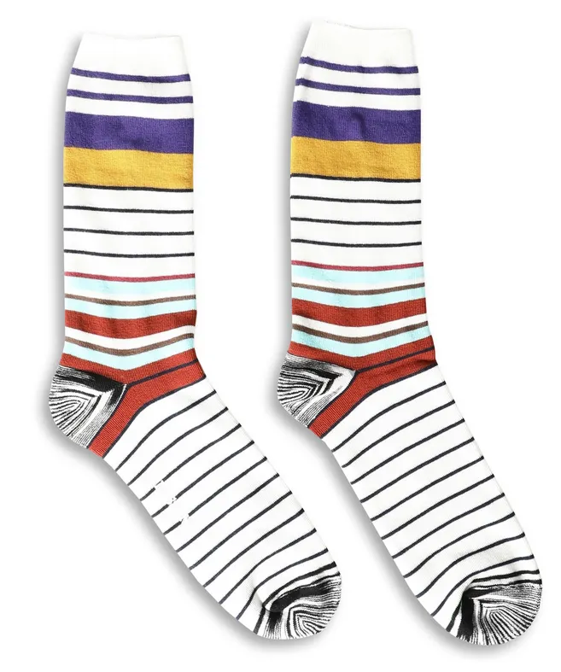  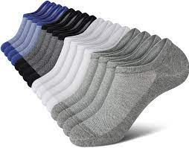
Socks, Tights:
- Tights must be white, black, navy blue or gray.
- Tights should be solid-colored and cannot have any visible patterns, words or designs.
- Knee socks worn with skirts should also be white, black, navy blue, or gray
Undershirts:  - Short sleeved undershirts can be any color.  - Long sleeved undershirts that are visible under a short sleeved uniform shirt need to be navy blue, white, black, or gray with no visible pattern, words or design. | 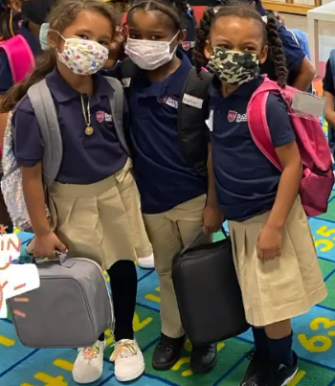  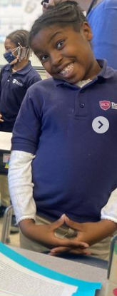  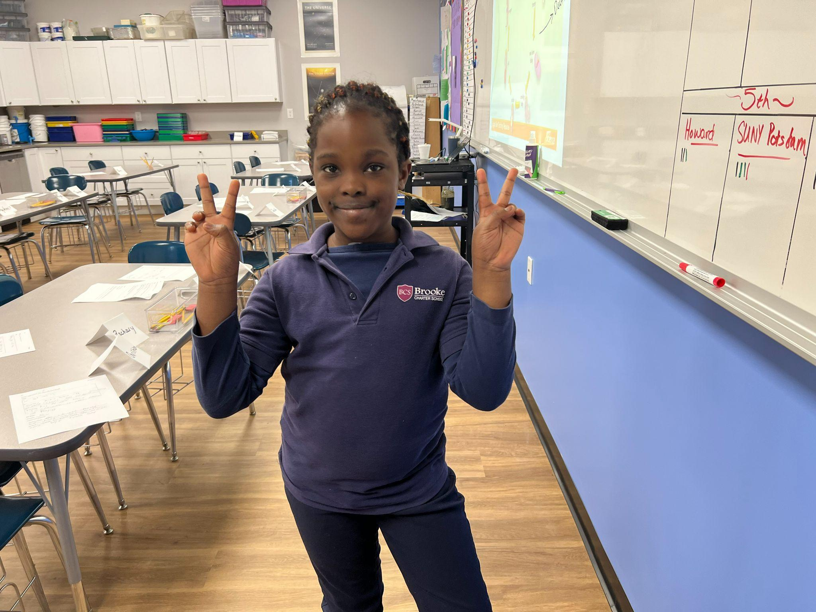

Accessories:
- Scholars can wear any necklaces, bracelets, rings, earrings or hair accessories. We reserve the right to ask scholars to remove bracelets or necklaces if they are distracting from learning or convey inappropriate messages.
- Scholars can wear regular watches. Scholars cannot wear smartwatches of any kind (Fitbits, Apple Watches, etc.)
- Scholars can wear any kind of belt. We recommend that small children not wear belts because they often lead to bathroom accidents.
- Scholars cannot wear hats during the school day.
For Kindergarten, First and Second Grade Families:
Kids in kindergarten, first grade and second grade are encouraged to bring a change of uniform clothing to keep at school in case of bathroom accidents.

Articles of Clothing that We Do Not Accept
If your child comes in with one of these, we will contact you to ask for permission to try to fix it, or you may be asked to bring a change of clothes. If you are unable to bring a change of clothes and we are unable to fix it with our inventory, your child will remain in the Main Office until we are able to find a solution.

(Please note that the images are listed for reference only and not an exhaustive list.)
All scholars need to wear black, navy or khaki uniform skirts, shorts or pants:  Scholars cannot come in leggings or jeans. | 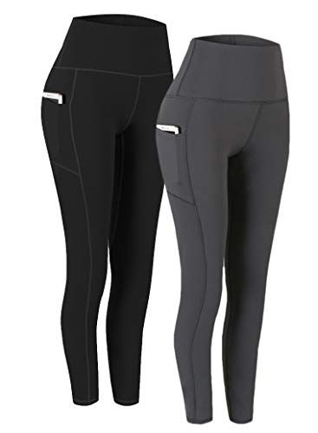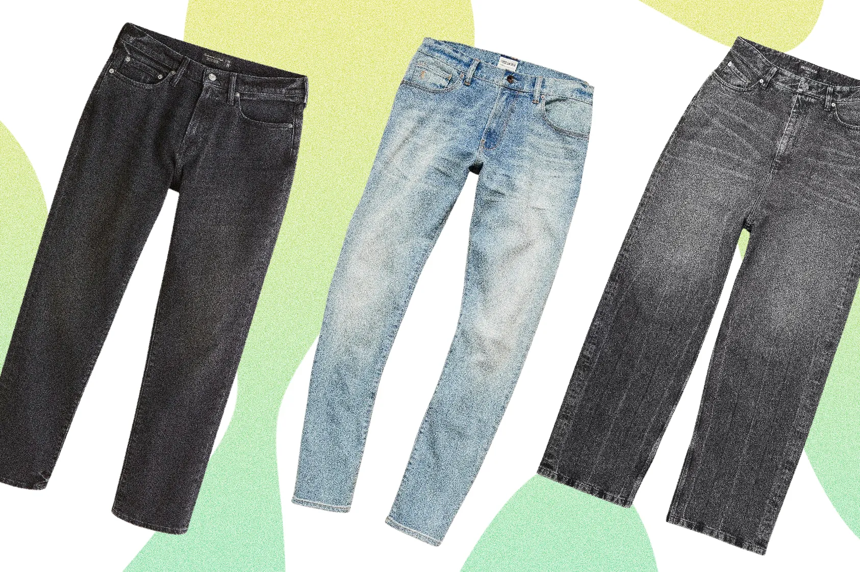
All scholars need to wear black, navy or khaki uniform skirts, shorts or pants:  Scholars cannot wear jumpers except the Lands’ End navy-blue option with the Brooke shield logo. | 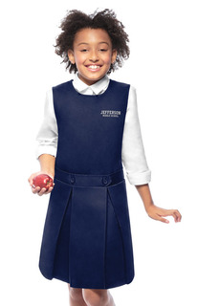
Footwear:  Scholars cannot wear sneakers that light up or have wheels.  Dress shoes, dress slippers, boots, and crocs are also not allowed. | 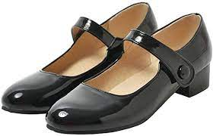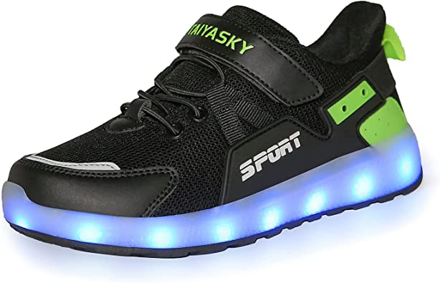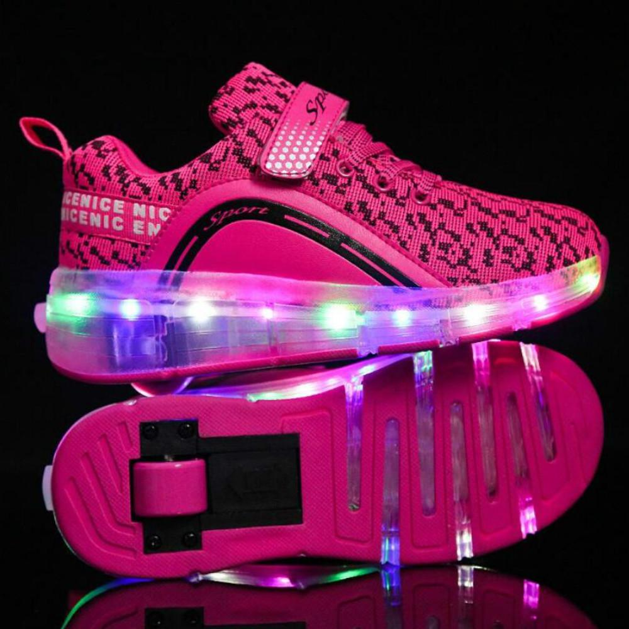
Socks, tights and undershirts:  Long sleeved undershirts must be navy blue, white, black, or gray with no visible pattern, words or design  To the right, you will see one example of what is not accepted (a navy blue t-shirt with yellow long sleeve). | 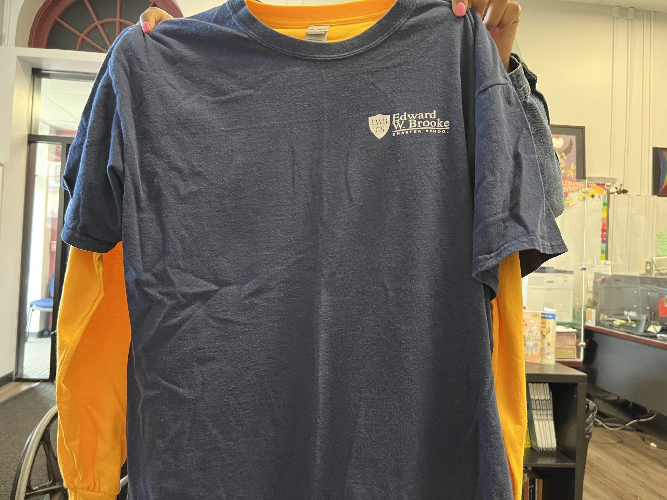
Accessories:  Scholars can wear regular watches.  Scholars cannot wear smartwatches of any kind (Fitbits, Apple Watches, etc.) |   